Project Design Phase
Solution Architecture

Date | 29.09.2026
Team ID | 6AP3D7136F290BE8A6B32917
Project Name | AI FAQ ASSISTANT API
Maximum Marks | 4 Marks

Solution Architecture
The AI FAQ Assistant API uses a modular RESTful backend architecture to manage FAQ information and provide AI-powered question answering. The system receives requests from the user through an API client such as Postman. The requests are processed by the Express.js server through routes, authentication and validation middleware, and controllers. The controllers communicate with MongoDB through Mongoose for FAQ and user data, while AI-related requests are processed through the Google Gemini AI service. The final result is returned to the client as a JSON response.
Solution Architecture and Data Flow of AI FAQ Assistant API
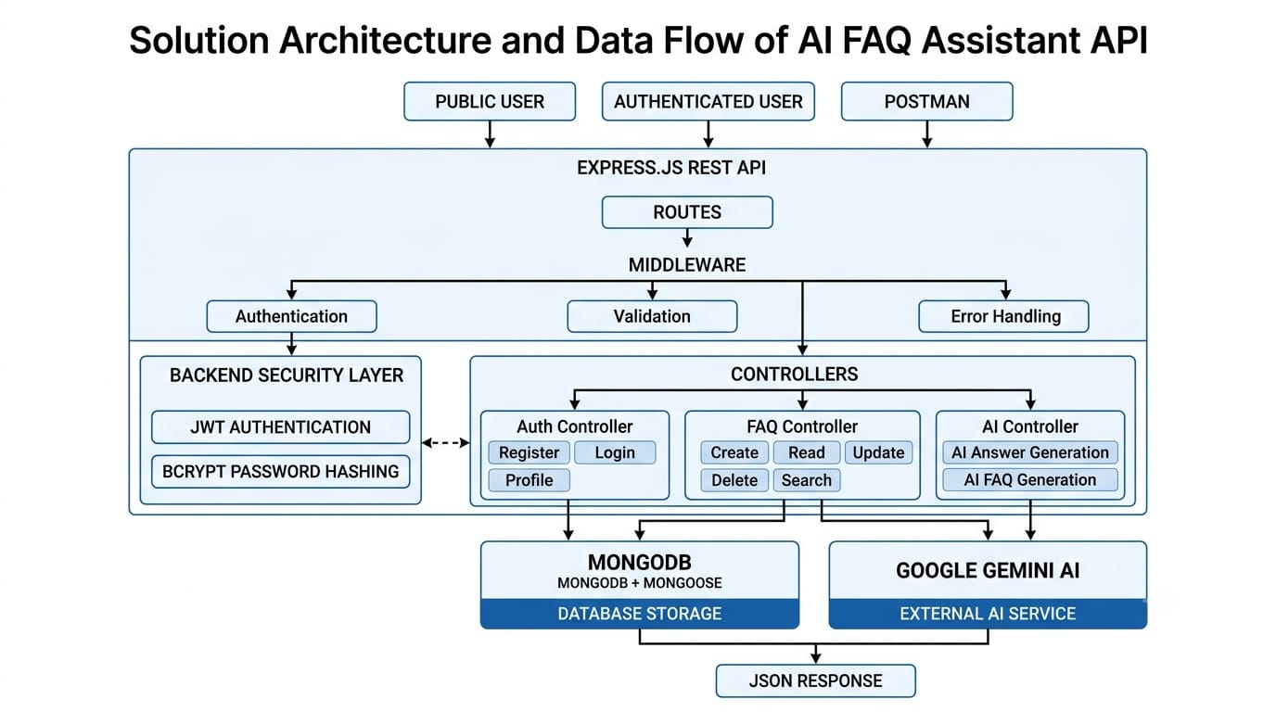

Reference: https://aws.amazon.com/blogs/industries/voice-applications-in-clinical-research-powered-by-ai-on-aws-part-1-architecture-and-design-considerations/

